**DOCUMENTATION FOR TS GOT TALENT APP**

1. SCREENSHOTS

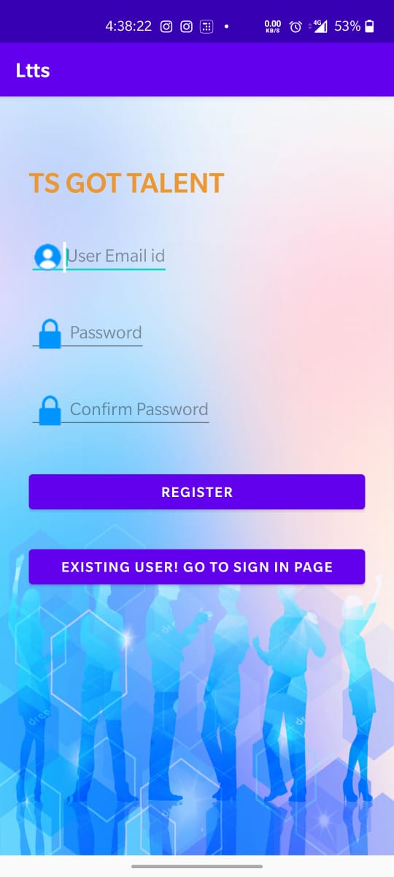 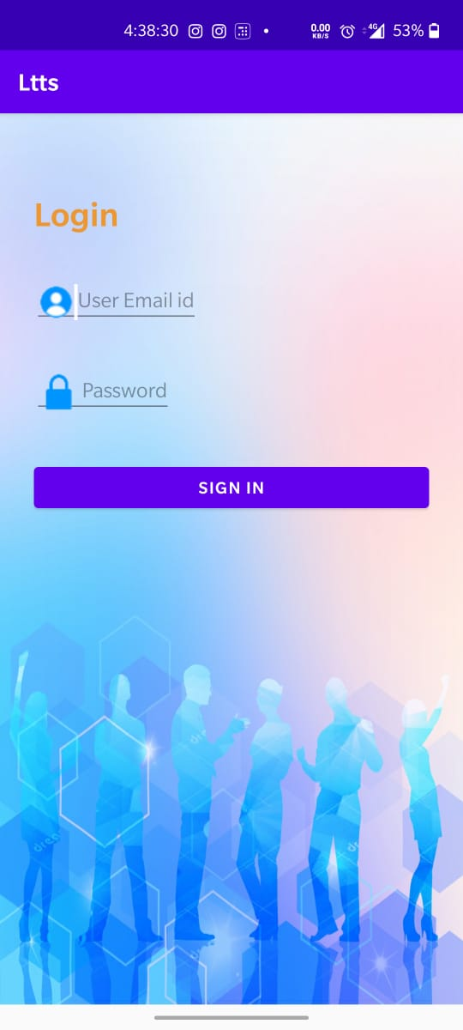

Fig 1: Resistration Activity Fig 2: Login Activity

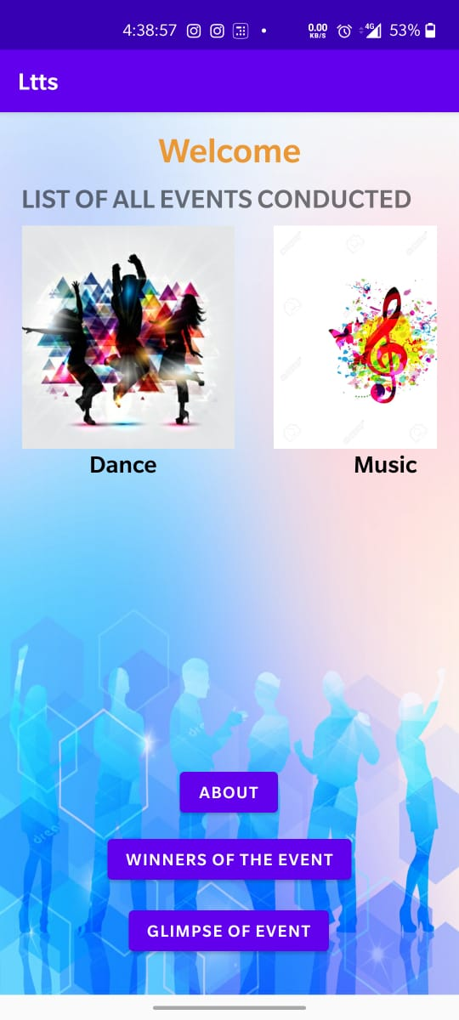 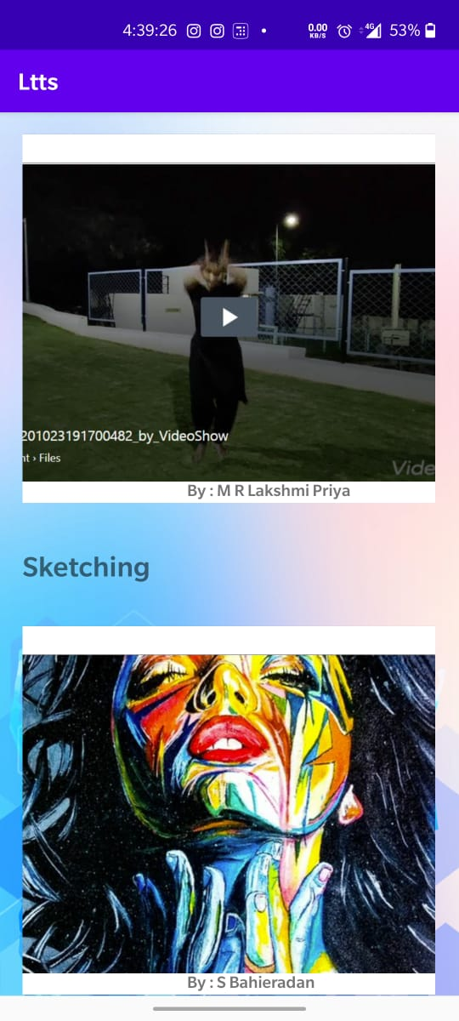

Fig 3: Welcome Activity Fig 4: Winners Activity

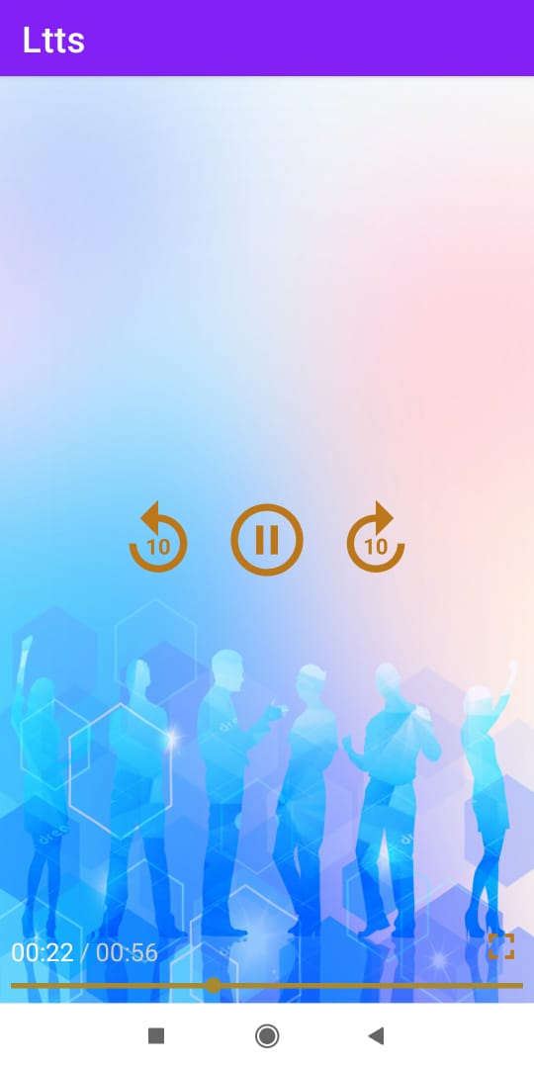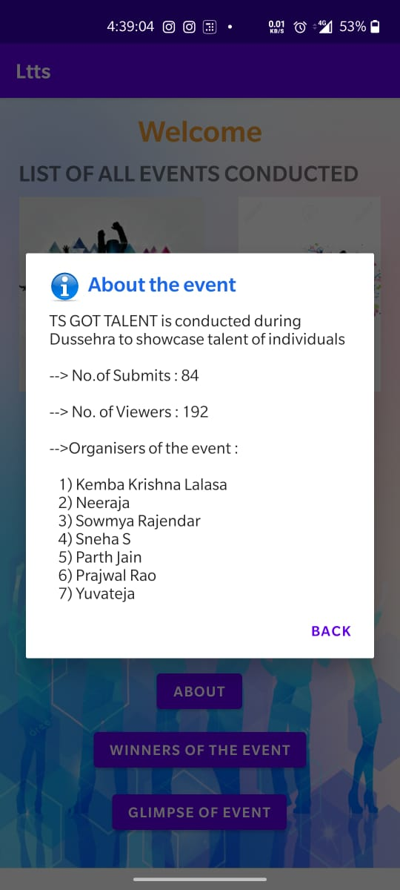

Fig 5: About the Event Fig 6: Exoplayer

1. Link to APK : <https://appetize.io/app/v1bwwg9jac89jwupfqjreyjz2r>
2. Link to GitHub : <https://github.com/99002474/Ltts>